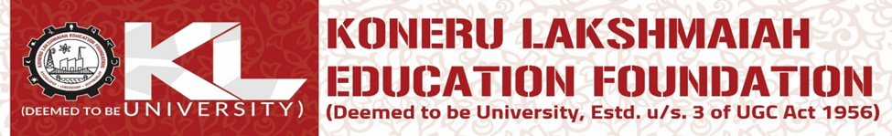
LAB EXPERIMENT-07
Program: B. Tech
Academic Year / Yr-Sem: 2025--26 [EVEN Sem]
Course Title & Code: FULL STACK APPLICATION DEVELOPMENT-[24SDCS02]

